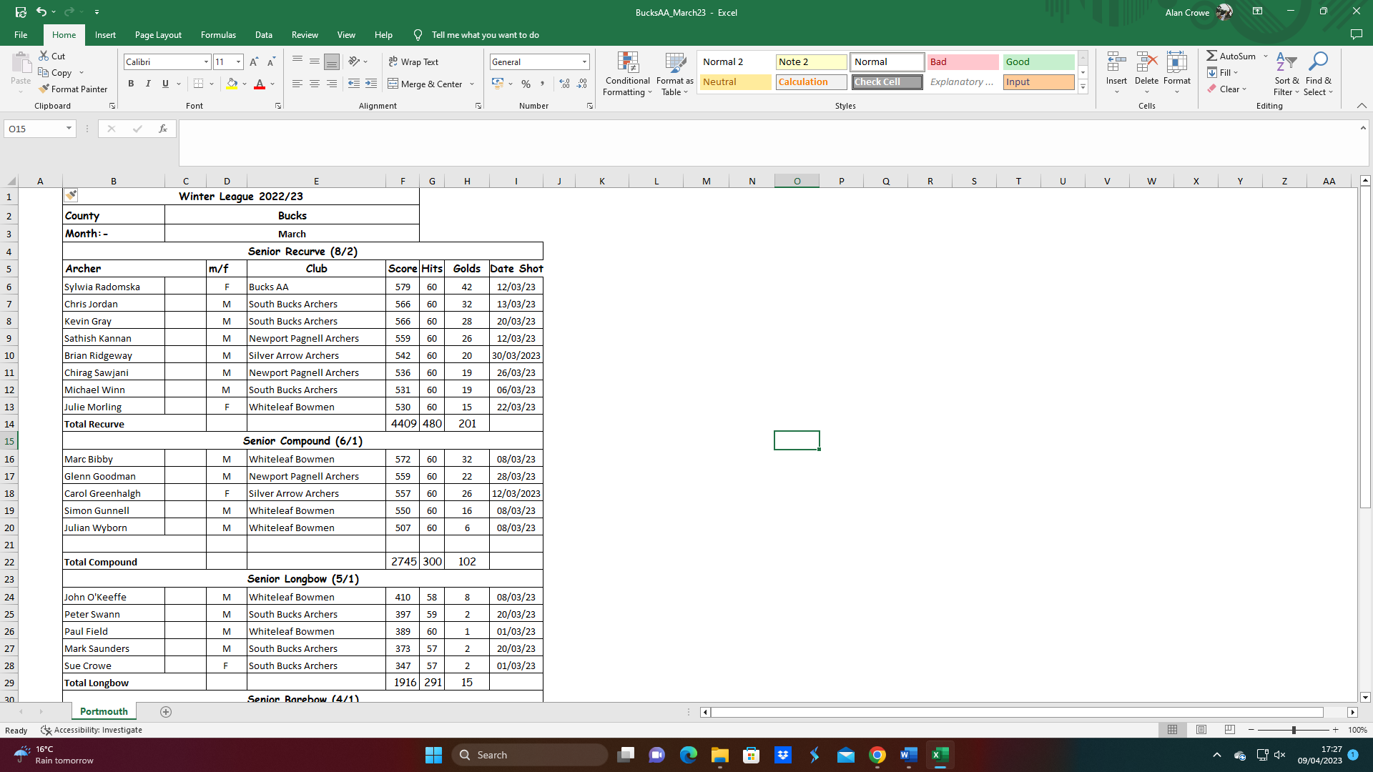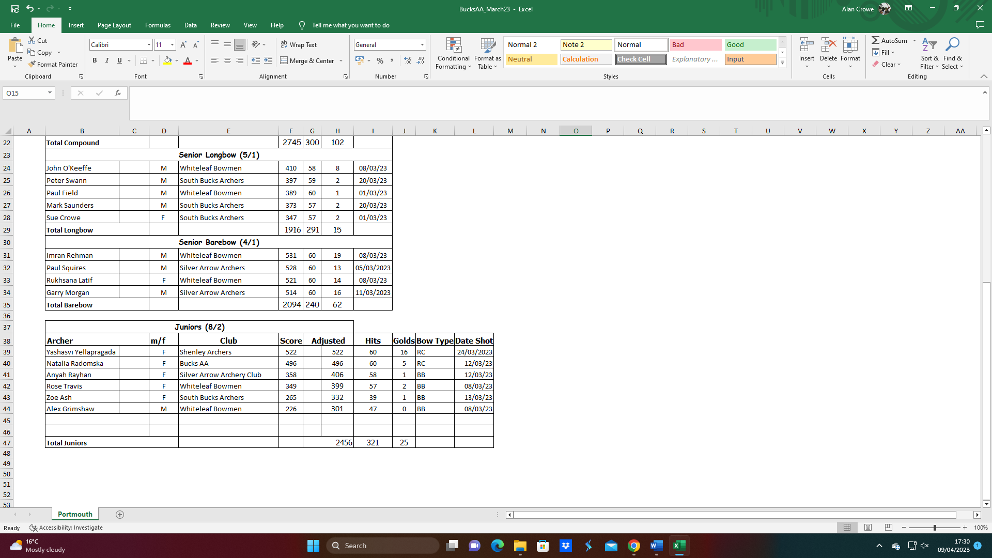**SCAS Postal Portsmouth – Bucks AA Teams March 23**



NOTE: Numbers in brackets (x/y)

x = total archers;

y = minimum female archers