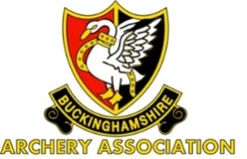

**Bucks AA Winter Portsmouth Postal Rules**

1. This will run alongside the SCAS Inter Counties Portsmouth Postal league.
2. Scores that were submitted for consideration for inclusion in the SCAS league will be used.
3. Bow style divisions will be as per SCAS league, but separated into M, F, JB and JG.

* Recurve
* Compound
* Longbow
* Barebow

1. The round may be shot outside or indoors.
2. The Junior Competition will be based on their ADJUSTED SCORES.
3. Juniors turning 18 during the season will be classed as adults.
4. Points will be awarded as follows:

|  |  |  |  |  |  |  |  |  |
| --- | --- | --- | --- | --- | --- | --- | --- | --- |
| 1st =20 | 2nd =17 | 3rd =14 | 4th =12 | 5th =10 | 6th =8 | 7th = 6 | 8th =4 | 9th = 2 |

all other submissions =1.

1. Gold and silver medals will be presented to the 1st and 2nd placed archers in each category.
2. **Scores to be sent to the Organizer by 5th of month**.

**Administration**

1. Entry is free to clubs affiliated to Bucks AA.
2. Each club to have a named coordinator/team manager responsible for the submission of scores to the Organizer.
3. No archers are to submit directly to the Organizer. Any scores submitted directly to the Organizer will be ignored.

Organizer – Alan Crowe – [alanjamescrowe@gmail.com](mailto:alanjamescrowe@gmail.com)