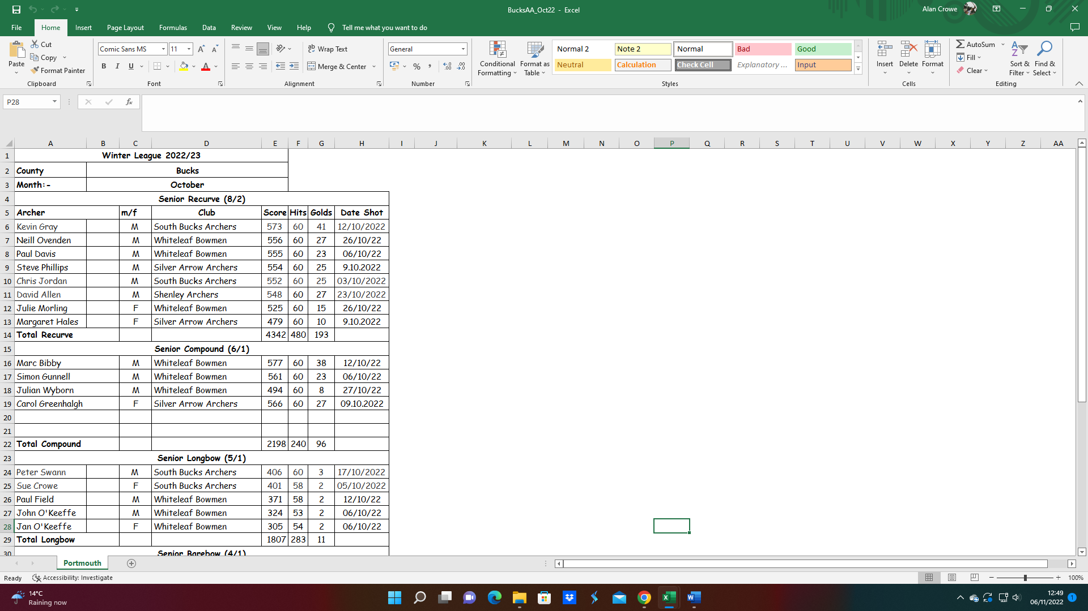**SCAS Postal Portsmouth – Bucks AA Teams October 22**

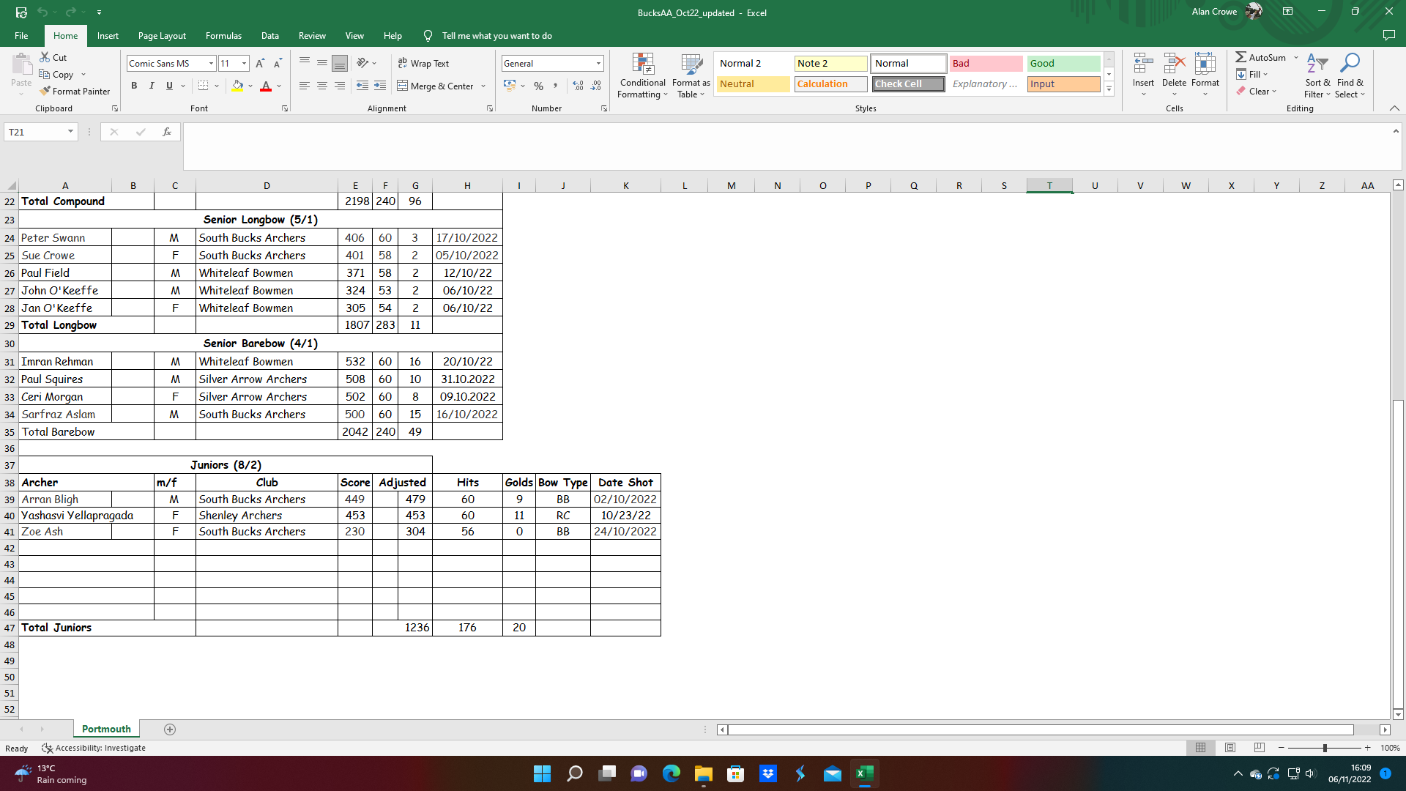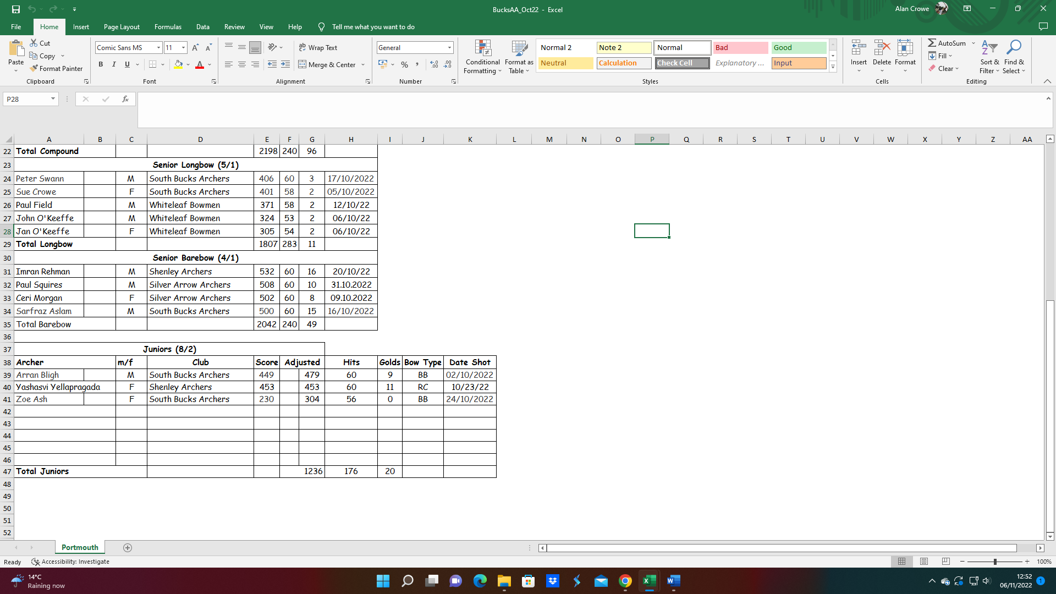

NOTE: Numbers in brackets (x/y)

x = total archers; y = minimum female archers